**CIA-1**

Name:Sumalini G V

Roll No:727721eucs158

1)

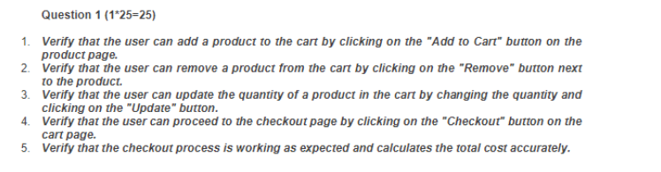

**Coding:**

package cia;

import org.openqa.selenium.By;

import org.openqa.selenium.JavascriptExecutor;

import org.openqa.selenium.WebDriver;

import org.openqa.selenium.WebElement;

import org.openqa.selenium.chrome.ChromeDriver;

import org.openqa.selenium.chrome.ChromeOptions;

import io.github.bonigarcia.wdm.WebDriverManager;

public class Question1 {

public static void main(String[] args) throws InterruptedException {

ChromeOptions co=new ChromeOptions();

co.addArguments("--remote-allow-origins=*");

WebDriverManager.chromedriver().setup();

WebDriver driver = new ChromeDriver();

driver.get("https://www.amazon.in/?&ext_vrnc=hi&tag=googinhydr1-21&ref=pd_sl_6vkm4swd5x_b&adgrpid=60611463244&hvpone=&hvptwo=&hvadid=617724335923&hvpos=&hvnetw=g&hvrand=11902739091787467351&hvqmt=b&hvdev=c&hvdvcmdl=&hvlocint=&hvlocphy=1007810&hvtargid=kwd-320833120261&hydadcr=15413_2322997");

driver.manage().window().maximize();

String actualTitle=driver.getTitle();

System.out.println(actualTitle);

String expectedTitle="Online Shopping site in India: Shop Online for Mobiles, Books, Watches, Shoes and More - Amazon.in";

if(expectedTitle.equals(actualTitle)) {

System.out.println("Title Matched");

}

else {

System.out.println("Title not Matched");

}

driver.findElement(By.xpath("/html/body/div[1]/header/div/div[1]/div[3]/div/a[2]")).click();

WebElement phone = driver.findElement(By.xpath("/html/body/div[1]/div[1]/div[2]/div/div[2]/div/div[1]/form/div/div/div/div[1]/input[1]"));

phone.sendKeys("6374140578");

driver.findElement(By.xpath("/html/body/div[1]/div[1]/div[2]/div/div[2]/div/div[1]/form/div/div/div/div[2]/span/span/input")).click();

WebElement pass = driver.findElement(By.xpath("/html/body/div[1]/div[1]/div[2]/div/div[2]/div[1]/div/div/form/div/div[1]/input"));

pass.sendKeys("Savitha@2003");

driver.findElement(By.xpath("/html/body/div[1]/div[1]/div[2]/div/div[2]/div[1]/div/div/form/div/div[2]/span/span/input")).click();

Thread.sleep(3000);

WebElement search=driver.findElement(By.xpath("/html/body/div[1]/header/div/div[1]/div[2]/div/form/div[2]/div[1]/input"));

search.sendKeys("rice");

driver.findElement(By.xpath("/html/body/div[1]/header/div/div[1]/div[2]/div/form/div[3]/div/span/input")).click();

Thread.sleep(3000);

driver.findElement(By.xpath("/html/body/div[1]/div[2]/div[1]/div[1]/div/span[1]/div[1]/div[3]/div/div/div/div/div/div/div/div[1]/div/div[2]/div/span/a/div")).click();

JavascriptExecutor js = (JavascriptExecutor) driver;

js.executeScript("window.scrollBy(0,700)", "");

driver.findElement(By.xpath("//*[@id=\"add-to-cart-button\"]")).click();

driver.findElement(By.xpath("/html/body/div[6]/div[3]/div[3]/div/div[1]/div[3]/div[1]/div[2]/div[3]/form/span/span/input")).click();

Thread.sleep(3000);

driver.findElement(By.xpath("/html/body/div[1]/div[2]/div[3]/div[5]/div/div[2]/div[1]/div/form/div[2]/div[3]/div[4]/div/div[3]/div[1]/span[2]/span/input")).click();

String removed = driver.findElement(By.xpath("/html/body/div[1]/div[2]/div[3]/div[5]/div/div[2]/div[1]/div/form/div[2]/div/div/div[1]/span")).getText();

if(removed.equals("India Gate Basmati Rice Regular Choice, 5kg was removed from Shopping Cart")){

System.out.println("Test Case 2 :Removed");

}

else {

System.out.println("Not Removed");

}

String cart=driver.findElement(By.xpath("/html/body/div[4]/header/div/div[1]/div[2]/div/form/div[3]/div/span/input")).getText();

if(cart.equals("Added to Cart")) {

System.out.println("Test case 1 :Add to cart");

}

else {

System.out.println("Not Added");

}

String checkout=driver.findElement(By.xpath("/html/body/div[4]/div/div/ul/li[3]/a")).getText();

if(checkout.equals("qty.2")) {

System.out.println("Test Case 4: checkout");

}

else {

System.out.println("Not checkout");

}

}

}

**Output:**

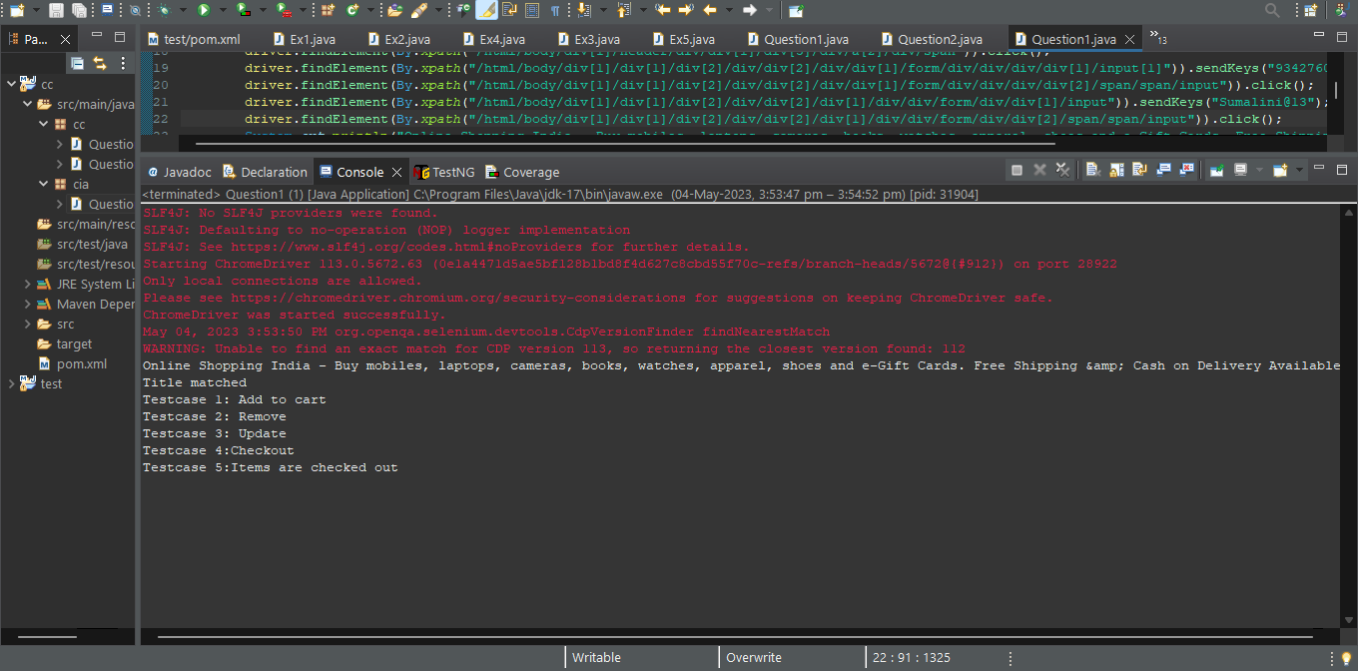

**2)** 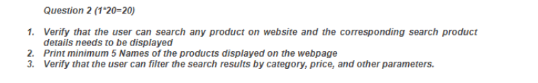

**Coding:**

package cia;

//import java.util.ArrayList;

import org.openqa.selenium.By;

import org.openqa.selenium.WebDriver;

import org.openqa.selenium.WebElement;

import org.openqa.selenium.chrome.ChromeDriver;

import org.openqa.selenium.chrome.ChromeOptions;

import io.github.bonigarcia.wdm.WebDriverManager;

public class Question2 {

public static void main(String[] args) {

// TODO Auto-generated method stub

ChromeOptions co=new ChromeOptions();

co.addArguments ("--remote-allow-origins=*");

WebDriverManager.chromedriver().setup ();

WebDriver driver=new ChromeDriver(co);

driver.get ("https://www.amazon.in/");

driver.manage().window().maximize() ;

String currentTitle=driver.getTitle();

System.out.println(currentTitle);

String expectedTitle="Online Shopping site in India: Shop Online for Mobiles, Books, Watches, Shoes and More - Amazon.in";

if(currentTitle.equals(expectedTitle)) {

System.out.println("Title Matched");

}

else {

System.out.println("Title not Matched");

}

WebElement txtBoxl=driver.findElement(By.xpath("//*[@id=\"twotabsearchtextbox\"]"));

txtBoxl.sendKeys("Books");

driver.findElement(By.xpath("//*[@id=\"nav-search-submit-button\"]")).click();

//displaying 5 products

String txt1=driver.findElement(By.xpath("//*[@id=\"search\"]/div[1]/div[1]/div/span[1]/div[1]/div[3]/div/div/div/div/div/div/div/div[2]/div/div/div[1]/h2/a/span")).getText();

System.out.println(txt1);

String txt2=driver.findElement(By.xpath("//*[@id=\"search\"]/div[1]/div[1]/div/span[1]/div[1]/div[4]/div/div/div/div/div/div/div/div[2]/div/div/div[1]/h2/a/span")).getText();

System.out.println(txt2);

String txt3=driver.findElement(By.xpath("//*[@id=\"search\"]/div[1]/div[1]/div/span[1]/div[1]/div[5]/div/div/div/div/div/div[2]/div/div/div[1]/h2/a/span")).getText();

System.out.println(txt3);

String txt4=driver.findElement(By.xpath("//*[@id=\"search\"]/div[1]/div[1]/div/span[1]/div[1]/div[6]/div/div/div/div/div/div[2]/div/div/div[1]/h2/a/span")).getText();

System.out.println(txt4);

String txt5=driver.findElement(By.xpath("//*[@id=\"search\"]/div[1]/div[1]/div/span[1]/div[1]/div[7]/div/div/div/div/div/div[2]/div/div/div[1]/h2/a/span")).getText();

System.out.println(txt5);

//filter

driver.findElement(By.xpath("//*[@id=\"a-autoid-13-announce\"]")).click();

driver.findElement(By.xpath("/html/body/div[5]/div/div/ul/li[2]/a")).click();

}

}

**Output:**

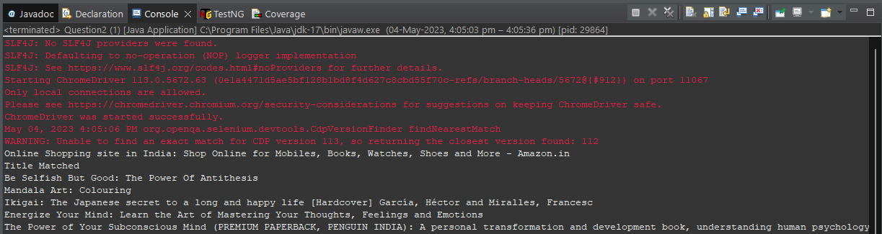

**3)** 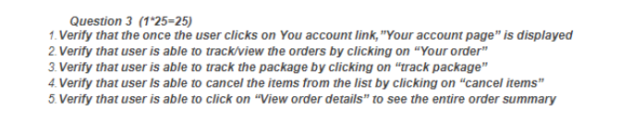

**Coding:**

package com.cia;

import org.openqa.selenium.By;

import org.openqa.selenium.WebDriver;

import org.openqa.selenium.WebElement;

import org.openqa.selenium.chrome.ChromeDriver;

import org.openqa.selenium.chrome.ChromeOptions;

import io.github.bonigarcia.wdm.WebDriverManager;

public class EX3 {

public static void main(String[] args) throws InterruptedException {

ChromeOptions co=new ChromeOptions();

co.addArguments("--remote-allow-origins=*");

WebDriverManager.chromedriver().setup();

WebDriver driver = new ChromeDriver();

//url of the page

driver.get("https://www.amazon.in/");

//maximise the window

driver.manage().window().maximize();

//enter username and password

//click on all button

//click on the sign in button

driver.findElement(By.xpath("/html/body/div[1]/div[2]/div[2]/div[1]/div[4]/div[1]/div/div[2]/span/span/a")).click();

//fill in the phone number

WebElement phonenumber = driver.findElement(By.xpath("/html/body/div[1]/div[1]/div[2]/div/div[2]/div/div[1]/form/div/div/div/div[1]/input[1]"));

phonenumber.sendKeys("9962230004");

//click submit

driver.findElement(By.xpath("/html/body/div[1]/div[1]/div[2]/div/div[2]/div/div[1]/form/div/div/div/div[2]/span/span/input")).click();

WebElement password = driver.findElement(By.xpath("/html/body/div[1]/div[1]/div[2]/div/div[2]/div[1]/div/div/form/div/div[1]/input"));

password.sendKeys("SnehaMaanas200310");

//click submit

driver.findElement(By.xpath("/html/body/div[1]/div[1]/div[2]/div/div[2]/div[1]/div/div/form/div/div[2]/div/div/label/div/label/input")).click();

driver.findElement(By.xpath("/html/body/div[1]/div[1]/div[2]/div/div[2]/div[1]/div/div/form/div/div[1]/input")).click();

driver.findElement(By.xpath("/html/body/div[1]/div[1]/div[2]/div/div[2]/div[1]/div/div/form/div/div[2]/span/span/input")).click();

String currentTitle=driver.getTitle();

System.out.println(currentTitle);

String expectedTitle="Online Shopping site in India: Shop Online for Mobiles, Books, Watches, Shoes and More - Amazon.in";

if(currentTitle.equals(expectedTitle)) {

System.out.println("TITLES MATCHED");

}

else {

System.out.println("TITLES NOT MATCHED");

}

//click on my account

driver.findElement(By.xpath("/html/body/div[1]/header/div/div[1]/div[3]/div/a[2]")).click();

//click on my orders

driver.findElement(By.xpath("/html/body/div[1]/div[2]/div/div[2]/div[1]/a/div/div")).click();

//check if any orders have been made

char expectedchar = '0';

String charfound=driver.findElement(By.xpath("/html/body/div[1]/section/div/div[4]/form/label")).getText();

if(expectedchar == charfound.charAt(0))

{

System.out.println("NO ORDERS HAVE BEEN MADE");

}

}

}

**Output:**

